**Unit-2**

**Linear regression** is one of the easiest and most popular Machine Learning algorithms. It is a statistical method that is used for predictive analysis. Linear regression makes predictions for continuous/real or numeric variables such as sales, salary, age, product price, etc.

**Linear regression algorithm** shows a linear relationship between a dependent (y) and one or more independent (y) variables, hence called as linear regression. Since linear regression shows the linear relationship, which means it finds how the value of the dependent variable is changing according to the value of the independent variable.

The linear regression model provides a sloped straight line representing the relationship between the variables. Consider the below image:

**Linear Regression in Machine Learning**

Mathematically, we can represent a linear regression as:

**y= a0+a1x+ ε**

Here,

Y= Dependent Variable (Target Variable)

X= Independent Variable (predictor Variable)

a0= intercept of the line (Gives an additional degree of freedom)

a1 = Linear regression coefficient (scale factor to each input value).

ε = random error

The values for x and y variables are training datasets for Linear Regression model representation.

**Types of Linear Regression**

Linear regression can be further divided into two types of the algorithm:

**Simple Linear Regression:**

If a single independent variable is used to predict the value of a numerical dependent variable, then such a Linear Regression algorithm is called Simple Linear Regression.

**Multiple Linear regression:**

If more than one independent variable is used to predict the value of a numerical dependent variable, then such a Linear Regression algorithm is called Multiple Linear Regression.

**Linear Regression Line**

A linear line showing the relationship between the dependent and independent variables is called a regression line. A regression line can show two types of relationship:

**Positive Linear Relationship:**

If the dependent variable increases on the Y-axis and independent variable increases on X-axis, then such a relationship is termed as a Positive linear relationship.

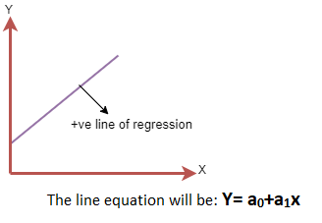

**Negative Linear Relationship:**

If the dependent variable decreases on the Y-axis and independent variable increases on the X-axis, then such a relationship is called a negative linear relationship.

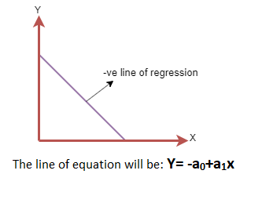

**Finding the best fit line:**

When working with linear regression, our main goal is to find the best fit line that means the error between predicted values and actual val ues should be minimized. The best fit line will have the least error.

The different values for weights or the coefficient of lines (a0, a1) gives a different line of regression, so we need to calculate the best values for a0 and a1 to find the best fit line, so to calculate this we use cost function.

**Cost function-**

The different values for weights or coefficient of lines (a0, a1) gives the different line of regression, and the cost function is used to estimate the values of the coefficient for the best fit line.

Cost function optimizes the regression coefficients or weights. It measures how a linear regression model is performing.

We can use the cost function to find the accuracy of the mapping function, which maps the input variable to the output variable. This mapping function is also known as Hypothesis function.

For Linear Regression, we use the **Mean Squared Error (MSE) cost function**, which is the average of **squared error** occurred between the predicted values and **actual values.** It can be written as:

For the above linear equation, MSE can be calculated as:

Linear Regression in Machine Learning

Where,

N=Total number of observation

Yi = Actual value

(a1xi+a0)= Predicted value.

**Residuals:**

The distance between the actual value and predicted values is called residual. If the observed points are far from the regression line, then the residual will be high, and so cost function will high. If the scatter points are close to the regression line, then the residual will be small and hence the cost function.

**Classification Algorithms:**

The Classification algorithm is a Supervised Learning technique that is used to identify the category of new observations on the basis of training data. In Classification, a program learns from the given dataset or observations and then classifies new observation into a number of classes or groups. Such as, **Yes or No, 0 or 1, Spam or Not Spam, cat or dog,** etc. Classes can be called as targets/labels or categories.

The best example of an ML classification algorithm is **Email Spam Detector**.

Classification algorithms can be better understood using the below diagram. In the below diagram, there are two classes, class A and Class B. These classes have features that are similar to each other and dissimilar to other classes.

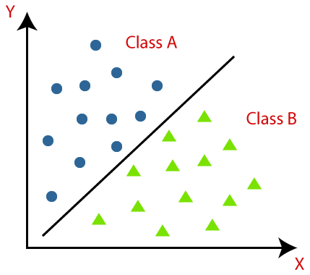

In the classification problems, there are two types of learners:

1. **Lazy Learners:** Lazy Learner firstly stores the training dataset and wait until it receives the test dataset. In Lazy learner case, classification is done on the basis of the most related data stored in the training dataset. It takes less time in training but more time for predictions.  
   **Example:** K-NN algorithm, Case-based reasoning
2. **Eager Learners:** Eager Learners develop a classification model based on a training dataset before receiving a test dataset. Opposite to Lazy learners, Eager Learner takes more time in learning, and less time in prediction. **Example:** Decision Trees, Naïve Bayes, ANN.

The algorithm which implements the classification on a dataset is known as a classifier. There are two types of Classifications:

1. **Binary Classifier:** If the classification problem has only two possible outcomes, then it is called as Binary Classifier.  
   **Examples:** YES or NO, MALE or FEMALE, SPAM or NOT SPAM, CAT or DOG, etc.
2. **Multi-class Classifier:** If a classification problem has more than two outcomes, then it is called as Multi-class Classifier.  
   **Example:** Classifications of types of crops, Classification of types of music.

**Underfitting**

A statistical model is said to have under-fitting when it cannot capture the underlying trend of the data.

It usually happens if we have less data to train our model, but quite high amount of features, Or when we try to build a linear model with a non-linear data. In such cases the rules of the machine learning model are too easy and flexible to be applied on such a minimal data and therefore the model will probably make a lot of wrong predictions.

# Overfitting

Overfitting occurs when a statistical model or machine learning algorithm captures the noise of the data. Intuitively, overfitting occurs when the model or the algorithm fits the data too well. Specifically, overfitting occurs if the model or algorithm shows **low bias** but **high variance**. Overfitting is often a result of an excessively complicated model applied to a not so complicated dataset.

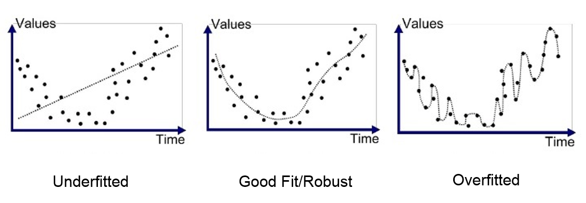

# Decision Tree Classification Algorithm

* Decision Tree is a **Supervised learning technique**that can be used for both classification and Regression problems, but mostly it is preferred for solving Classification problems. It is a tree-structured classifier, where**internal nodes represent the features of a dataset, branches represent the decision rules** and **each leaf node represents the outcome.**
* In a Decision tree, there are two nodes, which are the **Decision Node** and**Leaf Node.** Decision nodes are used to make any decision and have multiple branches, whereas Leaf nodes are the output of those decisions and do not contain any further branches.
* The decisions or the test are performed on the basis of features of the given dataset.
* **It is a graphical representation for getting all the possible solutions to a problem/decision based on given conditions.**
* It is called a decision tree because, similar to a tree, it starts with the root node, which expands on further branches and constructs a tree-like structure.
* In order to build a tree, we use the **CART algorithm,** which stands for **Classification and Regression Tree algorithm.**
* A decision tree simply asks a question, and based on the answer (Yes/No), it further split the tree into subtrees.
* Below diagram explains the general structure of a decision tree:

#### **Note: A decision tree can contain categorical data (YES/NO) as well as numeric data.**

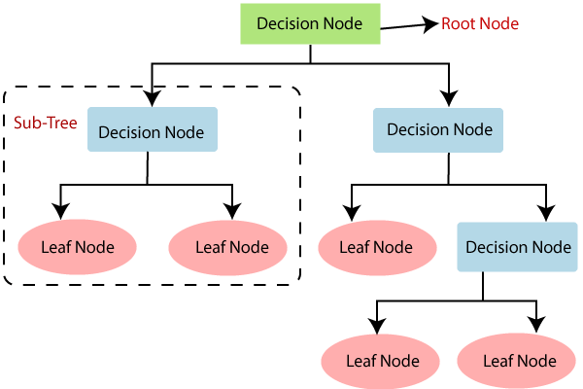

## **Why use Decision Trees?**

There are various algorithms in Machine learning, so choosing the best algorithm for the given dataset and problem is the main point to remember while creating a machine learning model. Below are the two reasons for using the Decision tree:

* Decision Trees usually mimic human thinking ability while making a decision, so it is easy to understand.
* The logic behind the decision tree can be easily understood because it shows a tree-like structure.

## **Decision Tree Terminologies**

• **Root Node:** Root node is from where the decision tree starts. It represents the entire dataset, which further gets divided into two or more homogeneous sets.

• **Leaf Node:** Leaf nodes are the final output node, and the tree cannot be segregated further after getting a leaf node.

• **Splitting:** Splitting is the process of dividing the decision node/root node into sub-nodes according to the given conditions.

• **Branch/Sub Tree:** A tree formed by splitting the tree.

• **Pruning:** Pruning is the process of removing the unwanted branches from the tree.

• **Parent/Child node:** The root node of the tree is called the parent node, and other nodes are called the child nodes.

**How does the Decision Tree algorithm Work?**

In a decision tree, for predicting the class of the given dataset, the algorithm starts from the root node of the tree. This algorithm compares the values of root attribute with the record (real dataset) attribute and, based on the comparison, follows the branch and jumps to the next node.

For the next node, the algorithm again compares the attribute value with the other sub-nodes and move further. It continues the process until it reaches the leaf node of the tree. The complete process can be better understood using the below algorithm:

3

* **Step-1:** Begin the tree with the root node, says S, which contains the complete dataset.
* **Step-2:** Find the best attribute in the dataset using **Attribute Selection Measure (ASM).**
* **Step-3:** Divide the S into subsets that contains possible values for the best attributes.
* **Step-4:** Generate the decision tree node, which contains the best attribute.
* **Step-5:** Recursively make new decision trees using the subsets of the dataset created in step -3. Continue this process until a stage is reached where you cannot further classify the nodes and called the final node as a leaf node.

**Example:** Suppose there is a candidate who has a job offer and wants to decide whether he should accept the offer or Not. So, to solve this problem, the decision tree starts with the root node (Salary attribute by ASM). The root node splits further into the next decision node (distance from the office) and one leaf node based on the corresponding labels. The next decision node further gets split into one decision node (Cab facility) and one leaf node. Finally, the decision node splits into two leaf nodes (Accepted offers and Declined offer). Consider the below diagram:

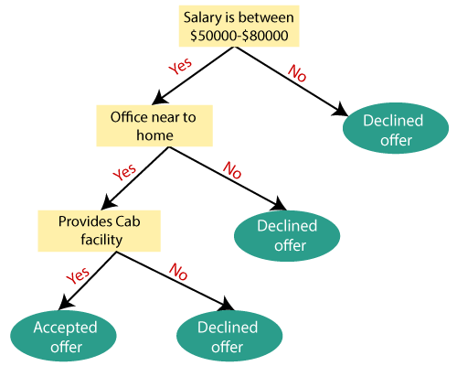

# Random Forest Algorithm

Random Forest is a popular machine learning algorithm that belongs to the supervised learning technique. It can be used for both Classification and Regression problems in ML. It is based on the concept of **ensemble learning,** which is a process of combining multiple classifiers to solve a complex problem and to improve the performance of the model.

As the name suggests, ***"Random Forest is a classifier that contains a number of decision trees on various subsets of the given dataset and takes the average to improve the predictive accuracy of that dataset."*** Instead of relying on one decision tree, the random forest takes the prediction from each tree and based on the majority votes of predictions, and it predicts the final output.

**The greater number of trees in the forest leads to higher accuracy and prevents the problem of overfitting.**

The below diagram explains the working of the Random Forest algorithm

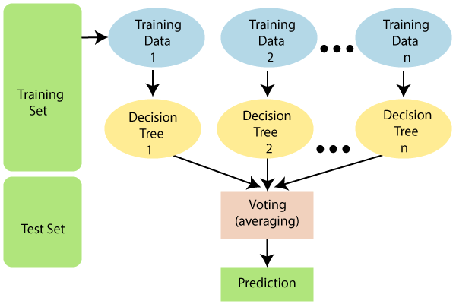

#### **Note: To better understand the Random Forest Algorithm, you should have knowledge of the Decision Tree Algorithm.**

## **Assumptions for Random Forest**

Since the random forest combines multiple trees to predict the class of the dataset, it is possible that some decision trees may predict the correct output, while others may not. But together, all the trees predict the correct output. Therefore, below are two assumptions for a better Random forest classifier:

* There should be some actual values in the feature variable of the dataset so that the classifier can predict accurate results rather than a guessed result.
* The predictions from each tree must have very low correlations.

## **Why use Random Forest?**

Below are some points that explain why we should use the Random Forest algorithm:

<="" li="">

* It takes less training time as compared to other algorithms.
* It predicts output with high accuracy, even for the large dataset it runs efficiently.
* It can also maintain accuracy when a large proportion of data is missing.

## **How does Random Forest algorithm work?**

Random Forest works in two-phase first is to create the random forest by combining N decision tree, and second is to make predictions for each tree created in the first phase.

The Working process can be explained in the below steps and diagram:

**Step-1:** Select random K data points from the training set.

**Step-2:** Build the decision trees associated with the selected data points (Subsets).

**Step-3:** Choose the number N for decision trees that you want to build.

**Step-4:** Repeat Step 1 & 2.

**Step-5:** For new data points, find the predictions of each decision tree, and assign the new data points to the category that wins the majority votes.

The working of the algorithm can be better understood by the below example:

**Example:** Suppose there is a dataset that contains multiple fruit images. So, this dataset is given to the Random forest classifier. The dataset is divided into subsets and given to each decision tree. During the training phase, each decision tree produces a prediction result, and when a new data point occurs, then based on the majority of results, the Random Forest classifier predicts the final decision. Consider the below image:

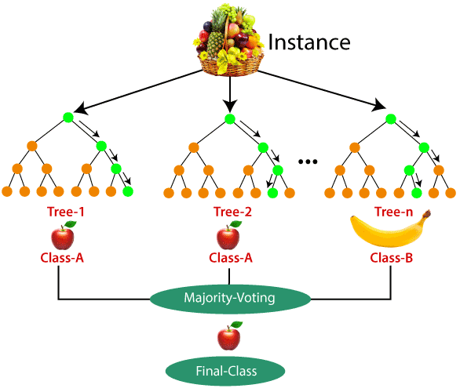

## **Applications of Random Forest**

There are mainly four sectors where Random forest mostly used:

1. **Banking:** Banking sector mostly uses this algorithm for the identification of loan risk.
2. **Medicine:** With the help of this algorithm, disease trends and risks of the disease can be identified.
3. **Land Use:** We can identify the areas of similar land use by this algorithm.
4. **Marketing:** Marketing trends can be identified using this algorithm.

## **Advantages of Random Forest**

* Random Forest is capable of performing both Classification and Regression tasks.
* It is capable of handling large datasets with high dimensionality.
* It enhances the accuracy of the model and prevents the overfitting issue.

## **Disadvantages of Random Forest**

* Although random forest can be used for both classification and regression tasks, it is not more suitable for Regression tasks.

**Ensemble** methods combine different decision trees to deliver better predictive results, afterward utilizing a single decision tree. The primary principle behind the ensemble model is that a group of weak learners come together to form an active learner.

There are two techniques given below that are used to perform ensemble decision tree.

## **Bagging**

Bagging is used when our objective is to reduce the variance of a decision tree. Here the concept is to create a few subsets of data from the training sample, which is chosen randomly with replacement. Now each collection of subset data is used to prepare their decision trees thus, we end up with an ensemble of various models. The average of all the assumptions from numerous tress is used, which is more powerful than a single decision tree.

**Random Forest** is an expansion over bagging. It takes one additional step to predict a random subset of data. It also makes the random selection of features rather than using all features to develop trees. When we have numerous random trees, it is called the Random Forest.

These are the following steps which are taken to implement a Random forest:

* Let us consider **X** observations **Y** features in the training data set. First, a model from the training data set is taken randomly with substitution.
* The tree is developed to the largest.
* The given steps are repeated, and prediction is given, which is based on the collection of predictions from n number of trees.

**Advantages of using Random Forest technique:**

* It manages a higher dimension data set very well.
* It manages missing quantities and keeps accuracy for missing data.

**Disadvantages of using Random Forest technique:**

Since the last prediction depends on the mean predictions from subset trees, it won't give precise value for the regression model.

## **Boosting:**

Boosting is another ensemble procedure to make a collection of predictors. In other words, we fit consecutive trees, usually random samples, and at each step, the objective is to solve net error from the prior trees.

If a given input is misclassified by theory, then its weight is increased so that the upcoming hypothesis is more likely to classify it correctly by consolidating the entire set at last converts weak learners into better performing models.

**Gradient** Boosting is an expansion of the boosting procedure.

1. Gradient Boosting = Gradient Descent + Boosting

It utilizes a gradient descent algorithm that can optimize any differentiable loss function. An ensemble of trees is constructed individually, and individual trees are summed successively. The next tree tries to restore the loss ( It is the difference between actual and predicted values).

**Advantages of using Gradient Boosting methods:**

* It supports different loss functions.
* It works well with interactions.

**Disadvantages of using a Gradient Boosting methods:**

* It requires cautious tuning of different hyper-parameters.

## **Difference between Bagging and Boosting:**

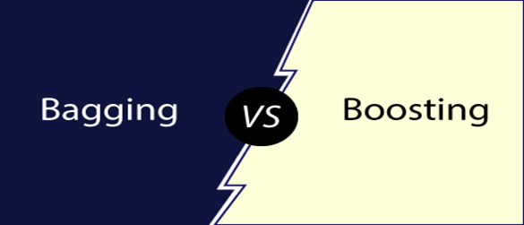

|  |  |
| --- | --- |
| **Bagging** | **Boosting** |
| Various training data subsets are randomly drawn with replacement from the whole training dataset. | Each new subset contains the components that were misclassified by previous models. |
| Bagging attempts to tackle the over-fitting issue. | Boosting tries to reduce bias. |
| If the classifier is unstable (high variance), then we need to apply bagging. | If the classifier is steady and straightforward (high bias), then we need to apply boosting. |
| Every model receives an equal weight. | Models are weighted by their performance. |
| Objective to decrease variance, not bias. | Objective to decrease bias, not variance. |
| It is the easiest way of connecting predictions that belong to the same type. | It is a way of connecting predictions that belong to the different types. |
| Every model is constructed independently. | New models are affected by the performance of the previously developed model. |